National Textile University, Faisalabad

Department of Computer Science
Name | Dawood Saif
Class | SE-6th (A)
Reg. No. | 23-NTU-CS-1145
Course | Mobile Application Development
Submitted To | Sir Rehan Sarwar
Submission Date | 16/03/2026
Lab Plan | 5

Create an App “Xylophone”,
- The app provides a graphical representation of a xylophone, usually with colorful bars or keys that resemble those of a real xylophone.
- Users can tap on the virtual xylophone bars to produce sounds.

Package: import 'package:audioplayers/audioplayers.dart';
Flutter Dependency: audioplayers: ^0.20.1

- Sounds Loaded:
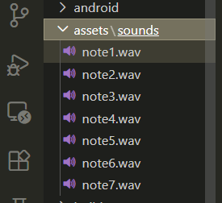

- Code Pic
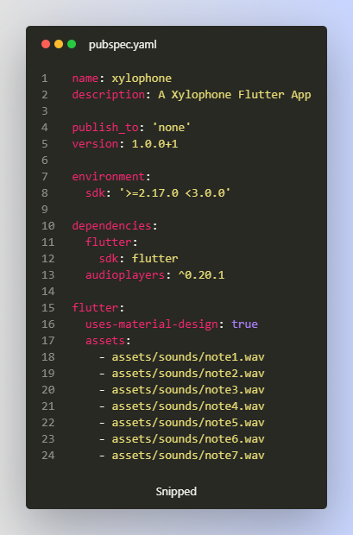

- Detailed Code
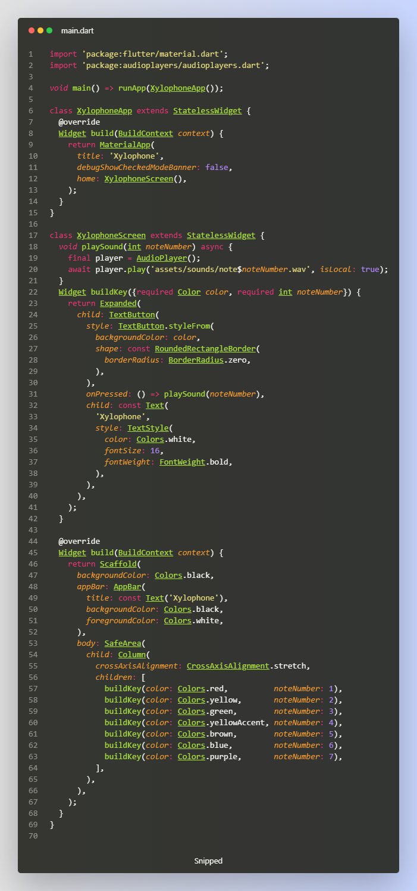

Output Screenshot:
